Budapest University of Technology and Economics
Faculty of Transportation Engineering and Vehicle Engineering
Department of Transport Technology and Economics
Master’s Thesis
Title of Thesis
2018

Contents (generated automatically)
page break

Introduction (Heading 1 style, size 16, bold)
This document contains the format specifications for thesis works written at the Department. It is edited according to the expected specifications, so it can be used as a template.
Page settings: A4 size, all margins 25 mm, with 10 mm gutter (if text is printed on one side, gutter is on the left, if it is printed on both side, gutter alternates). Page numbers are in the middle of the footer (bottom), and start from contents.
Body text’s font size is 12 pts, with 1.15…1.5 line space and 6 pt paragraph space (after the paragraph). Spell-check is advised.
Titles are in “Heading” style (for main titles Heading 1, 2nd level titles Heading 2 and so on) and they are numbered in decimal format. (If styles are set correctly, contents can be generated automatically.) Font of titles can differ from body text, size is 16 pts for main level, 14 pts for 2nd and 3rd level titles. Before and after all titles, there are 12 pts paragraph spaces.
More than 3 title levels are not advised; if lower subtitles are used anyway, they are not numbered (and not referenced in contents). Main chapters should start on new page.

Figures (Heading 2 style, size 14, bold, italics)
Figures and charts in the text should not be larger than 1 or 2 pages, more extensive ones should be placed in appendix. All figures have decimal numbering and caption under them (aligned to the middle). External references can be signed with numbers (e.g. [3]) or with full reference (web addresses should be in the same line if possible, without break). Self-edited figures do not have to be referenced.
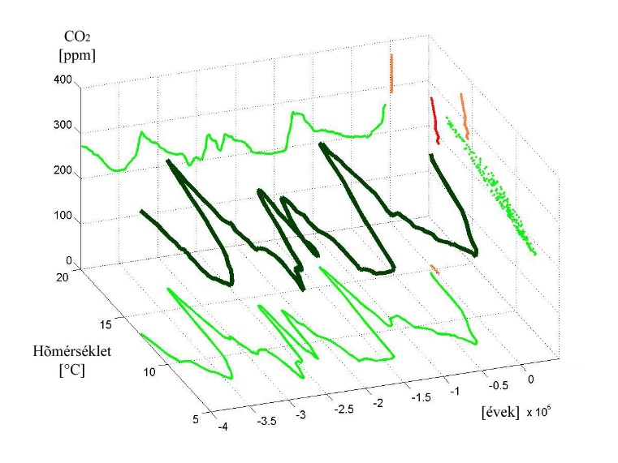
Figure 1: Caption
(Source: www.interestingfigures.com/3d_diagarams)
Before figures there are 12 pts, after them 6 pts spaces, and other 12 pts after caption. Figures should be referred in body text with their number (e.g. Figure 1). If figures’ captions are inserted with the matching function (“Insert caption”), Figure reference can be generated automatically. (Referring in text also should be inserted as cross-reference, because this way numbers can be refreshed easily.)

Charts
Format rules for charts are similar to figures. The main difference is the place of caption, which is on the top and aligned right. Spaces are 6, 6 and 12 points (before caption, before and after chart).
Table 1: Caption of table (Source: [2])
Class, from HUF/EUR | Class, to HUF/EUR | f_{i}  Appearance [pcs] | r_{i}  Relative frequency [%] | Σf_{i}  Aggregated appearance [pcs] | Σr_{i}  Aggr. relative frequency
113.53 | 128.95 | 6 | 3% | 6 | 3%
128.95 | 144.36 | 7 | 4% | 13 | 7%
144.36 | 159.78 | 1 | 1% | 14 | 8%
159.78 | 175.20 | 7 | 4% | 21 | 12%
175.20 | 190.61 | 8 | 4% | 29 | 16%
190.61 | 206.03 | 10 | 6% | 39 | 22%
206.03 | 221.44 | 6 | 3% | 45 | 25%
221.44 | 236.86 | 10 | 6% | 55 | 30%
236.86 | 252.28 | 58 | 32% | 113 | 62%
252.28 | 267.69 | 62 | 34% | 175 | 97%
267.69 | 283.11 | 5 | 3% | 180 | 99%
283.11 | 298.53 | 1 | 1% | 181 | 100%

References
External references in text signed with the number of source, in square brackets. [5] Cross-references should be used (in order to handle source number changes easily). Literal quotes have to be signed with quotation marks, as well.
Mathematical formulae also have to be numbered (with numbers in round brackets), and 12 pts spaces should be placed before and after them.
(1)

Third-level title (Heading 3 style, size 14)
Thesis work has to contain contents, introduction, at least 3 main chapters, conclusion, references, list of figures, list of charts, and – if needed – appendix.
  - Subtitle (Subtitle style, size 13)
Appendices are numbered and have a title. They are referred in text with their number (e.g. Appendix 1).

References (Heading 1 style, but without number!)
Book: (Like Heading 2, but Normal(!) style)
References are given in a numbered list (to make cross-references possible). “Reference-KUKG” style should be used (which has suitable settings). Subtitles in the references should be used only if at least 3 different kind of sources (book, journal etc.) appear. Besides sources from the internet, date of access also has to be marked.
- Author. Title. Place of publishing, Publisher, (year). pp. 12-15. ISBN 963 07 4580 1.
Journals:
- Bokor Z. és Tánczos K. Social costs of transport and their general and mode specific characteristics, Közlekedéstudományi Szemle, Vol. 53 No. 8, (2003), pp. 281–291. ISSN 0023-4362
Conference proceedings:
- Török Á. Road safety techniques in Hungary according to EU directives, MOSATT Proceedings on the Modern Safety Technologies in Transportation, Kosice, Slovakia, (2005), pp. 410–413.
Governmental and administration organizations:
- Munkaügyi Minisztérium, Humánpolitikai Osztály. Jelentés az 1998. évi munka-nélküliségi ráta alakulásáról. (MM-HO.1999 /348). Budapest, MM, (1999) pp. 32-41.
Research reports:
- Békefi Mihály [et. al.] Az ágazati hatékonyság értelmezése a költségtérítés odaítélésénél az autóbusz-közlekedésben. (KTI 271-8-043). Budapest, KTI Non-Profit Kft., (2009) pp. 19-22.
Electronic documents:
- Kovács László: NIIFP hálózati multimédia pilot projekt. Budapest, Sztaki, (1998) URL: http:// www.sztaki.hu/services /mbone
- History of the tram in Budapest. http://hampage.hu/trams/e_index.html, (access on 9th February, 2018)

